CSCE 211: Digital Logic Design Spring 2022
Homework 3 02/28/22
This homework consists of 8 questions. Please find the corresponding questions from Section 3.8 in your textbook.

1. (0.4 points) Plot the following function on the K-map: f = ac’ + a’bd’ + b’cd + ab’cd’. You have to circle each rectangle that represents a product term in the function and pull a line from each rectangle to specify the corresponding term.
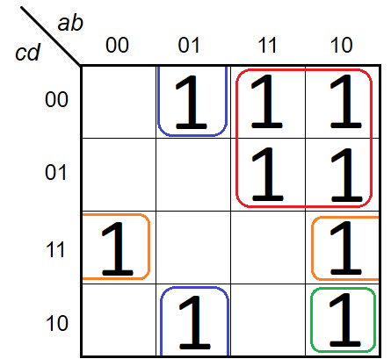
RED(AC’), BLUE(A’BD’), ORANGE(B’CD), GREEN(AB’CD’)

2. (0.3 points) Problem 2.a. f(a, b, c)=∑m(1, 2, 3, 6, 7)
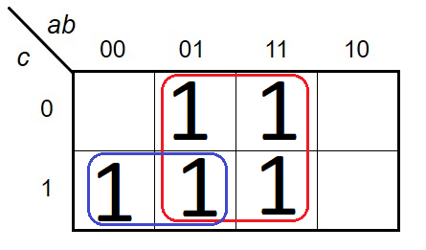

3. (0.4 points) Problem 2.d.
f(a, b, c, d)=∑m(1, 2, 3, 5, 6, 7, 8, 11, 13, 15)
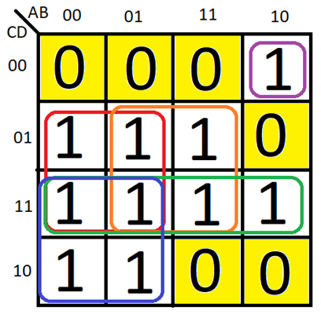

4. (0.4 points) Problem 2.h. Remember to show both of the 2 solutions.
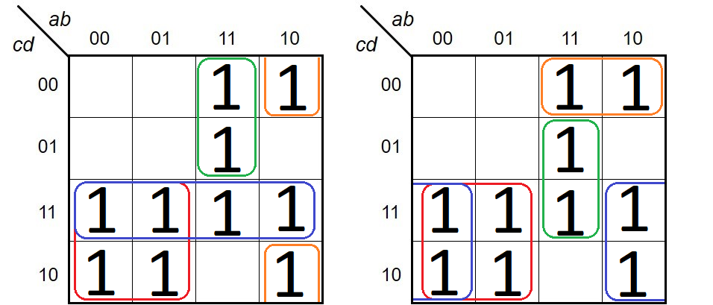
G=x’y+w’y+wxz+wy’z’

5. (0.4 points) Problem 2.k. Remember to show both of the 2 solutions.
f(w, x, y, z)=∑m(0, 1, 2, 4, 5, 6, 9, 10, 11, 13, 14, 15) (2 solutions)
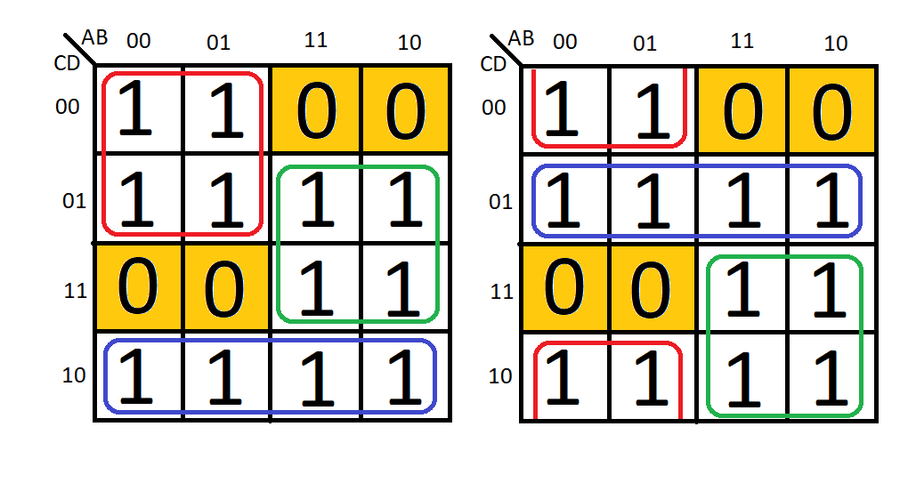

6. (0.4 points) Problem 3.a. Answer both i and ii.
f(a, b, c, d)=∑m(0, 3, 4, 5, 8, 11, 12, 13, 14, 15)
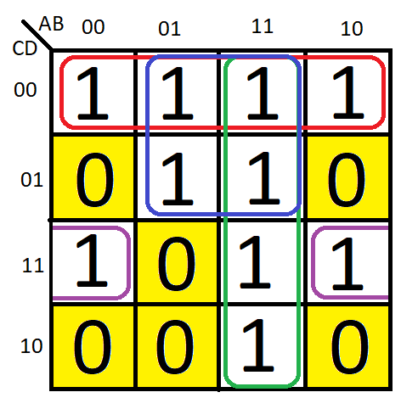

7. (0.8 points) Problem 5.e. Remember to show all 4 solutions.

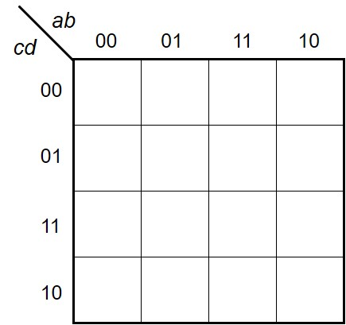



8. (0.9 points) Problem 7.j. Note that the problem requires you to find all of the minimum SOP expressions and also all of the minimum POS expressions.
f(a, b, c, d)=∑m(0, 1, 6, 15) +∑d(3, 5, 7, 11, 14) (1 SOP and 2 POS solutions)
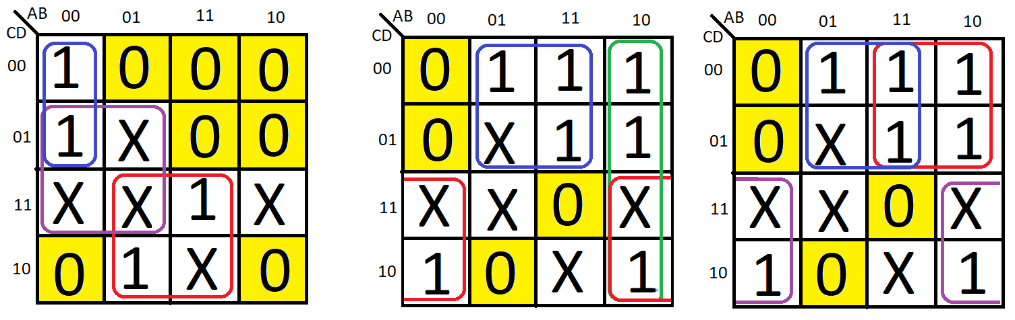
SOP
POS

